Exp 9 :
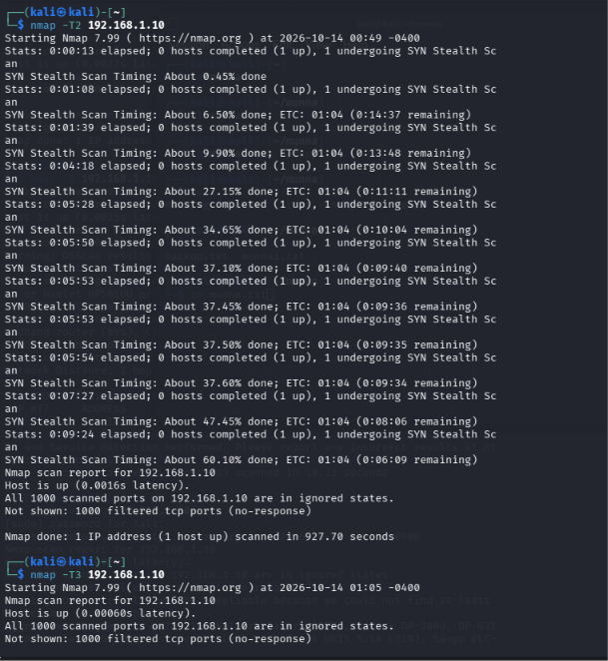

Exp 10 :
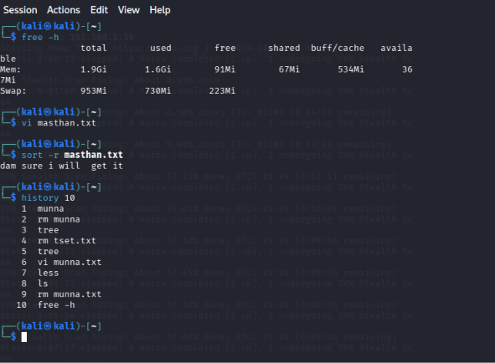

Experiment 11: Nmap Timing and Performance

(i) Aggressive Speed Scan
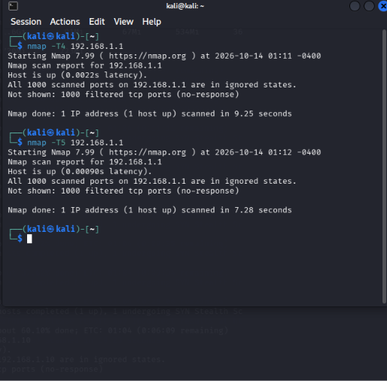

Experiment 12: Port Scanning Tools

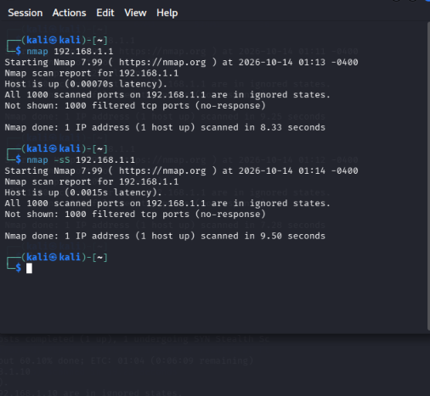

Experiment 13: Host Discovery

